**Website:** [**https://zeencollagen.com/**](https://zeencollagen.com/)

**Dated: 07/02/2020**

**PRROPOSAL FOR APP STORE OPTIMIZATION**

**ASO:**

**Stratgies for improved organic downloads and impressions:**

**Metrics to Track in App store optimization:**

1. **Keyword ranking**
2. **App Store impressions**
3. **Number of downloads**

**App store optimization is something that needs to be done on an ongoing basis just like SEO.it is crucial to understand the algorithm used by both app stores: some trick in Google play store won’t work in the Apple app store, so during optimization we need to be very careful about this.**

* **Apple app store ASO**
* **Google play store ASO**

**ON PAGE ASO:**

**Below are the Activities to make your app more visible and increase downloads**

1. **App Name and Keyword Research: It’s very important how to best define your app name and keywords.**
2. **App icon Design: App icon along with screenshot is an important asset and the first things user judges your app on. We must use unique icon to show the app differently from their competitor’s.**
3. **Catchy App description: Not everyone is going to read your full description (APP).we need to add catchy description which shows what is all about your app is.**
4. **Get the right App icon: choose the right app icon is an again another important factor. We will create the right icon which will correlate your business in every manner**
5. **Boost Traffic with promotion**
6. **Promotional Video: promotional video should be uploaded on regular interval.**
7. **Encourage user reviews: we must focus on Genuine reviews which gives more downloads and app ranking**
8. **App A/B Testing: This is important factor of ASO to use for identifying optimization**

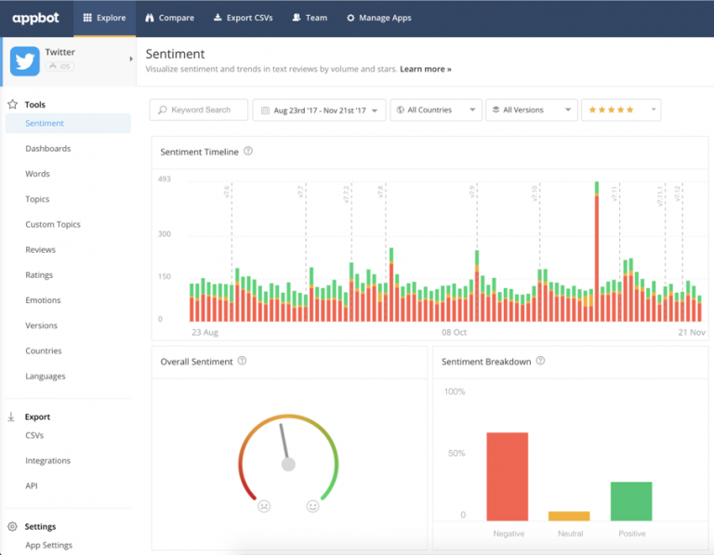

**Except On page ASO we should also focused on OFF PAGE ASO PROCESS: these are the activities which we would be doing on daily basis to promote the APP. Here we will be promoting your App using below activities by submission of article, blogs etc.**

**OFF PAGE ASO:**

1. **Bookmarking**
2. **Classifieds**
3. **Business Listings**
4. **Social Submissions**
5. **PPT and PDF submissions**
6. **Image and Info-graphic submissions**
7. **WEB 2.0**
8. **Blog Submission**
9. **Press Release Submission**
10. **Article Submission …many more**

## Social Media Promotion for ASO: Engagement on social media is very important in App store optimization.

1. **Facebook Page creation/likes/banner posting (APP)**
2. **Twitter page creation**
3. **Twitter followers and Daily Tweets**
4. **LinkedIn Account and posting/Articles on daily basis**
5. **LinkedIn connections**
6. **Instagram posting and increased followers on daily basis**
7. **Promotional Video**
8. **Pinterest: We will make the board and upload the pins (with catchy app descriptions and icon) on daily basis.**

**------------------------------------------------- End of Document----------------------------------------------------**